Kid’s Leadership Team
INFO PAGE

“Don’t let anyone think less of you because you are young. Be an example to all believers in what you say, in the way you live, in your love, your faith, and your purity.” -1 Timothy 4:12
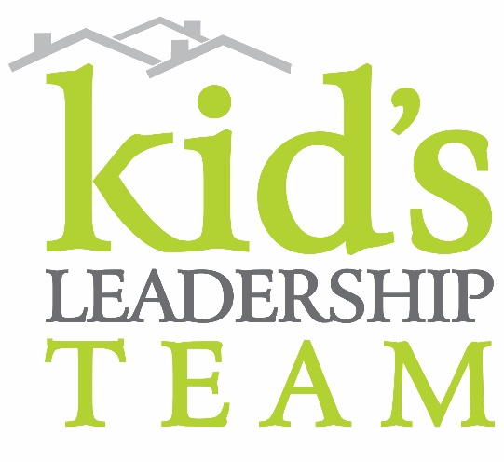
WHAT IS IT?
KLT exists to give kids (grades 2-5) an opportunity to
- GROW in their faith and biblical knowledge
- CONNECT to friends
- SERVE their community
It’s an opportunity for kids to go beyond what Sunday Services offer... We meet on the 1st and 3rd Wednesday evenings during the school year. Each Wednesday Team Time provides an opportunity for kids to explore God’s word, worship together, have fun and get involved in either a service project or learning opportunity.

WHAT SHOULD MY CHILD EXPECT?
WEDNESDAY TEAM TIME
7-720 Video LEARNING & Discussion
720-740 Large Group WORSHIP
740-830 Activity Time—This is when we go deeper, working on applying things that we have learned on Sundays and in KLT. Possibilities:
- SERVE opportunities (write letters to refugees, clean classrooms, prep materials for Sunday, help with weeding the church campus, etc.)
- GROW opportunities (guests teach us how they are using THEIR gifts and talents for Jesus, time exploring the Bible and working on ways to apply what we’ve learned, time exploring the ways WE are gifted and might use those gifts for Jesus)
- CONNECT opportunities (opportunities to connect with peers, to deepen friendships and welcome new friends to the table)

FAMILY SERVE OPPORTUNITIES
There will be a variety of serve opportunities during the year that include the whole family. This might be sorting food donations at Hopelink, singing and visiting residents at local Assisted Living Homes, serving dinner to the homeless community, etc. More info about this year’s projects to come.

KIDTOWN EVENTS
When KidTown hosts a special event such as KidTown Christmas, KLT will have the opportunity to lead as part of the worship team or serve team.

SUNDAY SERVE OPPORTUNITIES: Kids Worship Team
Kids who love to sing and dance can serve as WORSHIP leaders, as a part of the Kids Worship Team. There are 2 separate services that occur in our kid’s chapel on a Sunday. The first is our service for Kinders-2nd grade, and the later program is for 3rd-5th graders.

- 2nd graders on Sunday mornings
  - The K-2 grade chapel time is roughly 20 minutes and begins at 9:35 for 1st service, or 11:15 for 2nd service. Your kiddo will start their mornings in their classrooms like normal. They will then travel with their class to the chapel for worship and story. Once they arrive at chapel they may be asked to join the worship leader on stage for a couple of songs, or asked to help with a special task during the service. After singing, your child will rejoin their class for the duration of the morning and be picked up from their classroom.
- 3rd-5th graders on Sunday Mornings:
  - For our 1st service KWT kiddos, after they’ve been checked in, the worship leaders will come get them in the gym to participate in sound check. During sound check we will practice a couple songs and pray together as a team. They will then go back to the gym until all of the 3-5th graders return for the chapel portion of the morning at roughly 9:55. Chapel will consist of Game-Time, worship, story and small groups. Parent pick-up will be back at the gym.
  - For our 2nd service KWT kiddos, everything else is the same as the 1st service attenders except, the worship leaders will come get them at about 10:55 for sound check and chapel time will begin at 11:35am.

WHO CAN JOIN?
Any child in 2nd – 5th grade can join KLT. There is no application or fee for this program.

WHEN IS IT?
- Starts by the beginning of October every school year.
- Ends for the summer @ the beginning of June.
- Meets for TEAM TIME on the 1st and 3rd Wednesday of each month (except on special days).
- Time is from 7:00-8:30pm on Wednesdays.

WHERE IS IT?
Wednesdays. Red 7/8 (first hall on your left as you enter Overlake’s main entrance).

WHAT IS THE COMMITMENT?
Wednesdays. We hope kids can make it to every Wednesday night TEAM TIME, because that’s when deeper relationships develop! We realize that’s not reality for all families, so we are very flexible. Please plan on making it to at least one TEAM TIME per month.

WHAT DO I DO TO JOIN?
To join, please email kids@occ.org. We will give you the details you need and add you to our communications roster.

HOW CAN I GET UPDATED KLT INFORMATION?
Please like us on facebook at www.facebook.com/occkidtown. We make regular announcements for KLT on this page. Pastor Keri will send emails to those on the roster with regular updates, calendar info or schedule changes.

WHAT IS EXPECTED OF KLT PARENTS?
We ask several things of parents to make the program succeed:
- Please arrive on time on Wednesdays & Sundays if your child is serving with the KWT.
- Parents can definitely help on Wednesday nights. We need help with check in, escorting kids to the restrooms, facilitating some simple games or small group discussions.
- For Serve Projects, we’d love to have you serve WITH us.
- We always welcome your feedback!

--The KidTown Team

